**Cloud Computing Assignment Spring 2019, Assignment-2**

**Cloud Platform : Amazon AWS**

**Step-1 :** Create free account and login into Amazon AWS. Select EC2 and launch new instance.

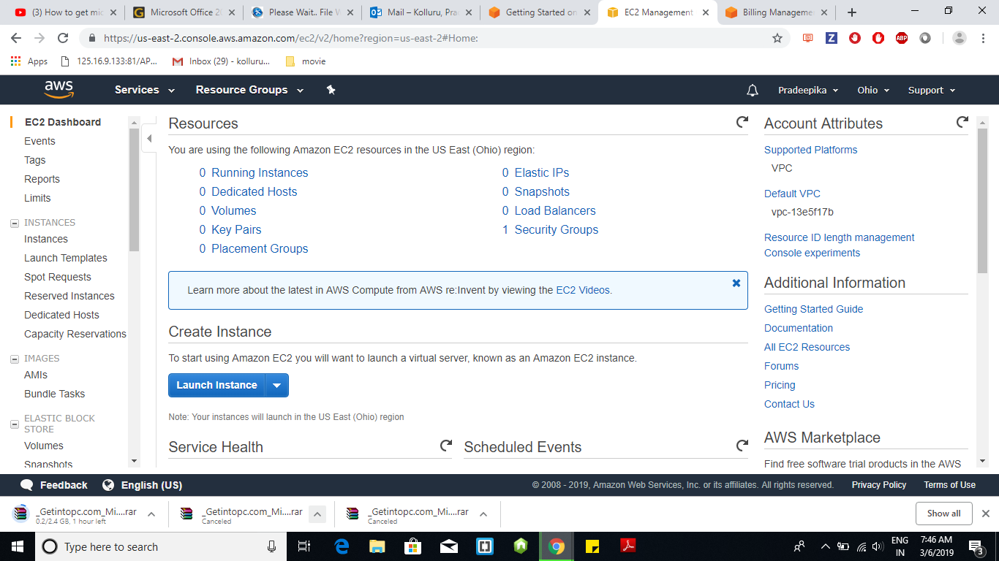

**Step-2 :** Choose any listed Amazon Machine Images. Here I selected Amazon Linux.

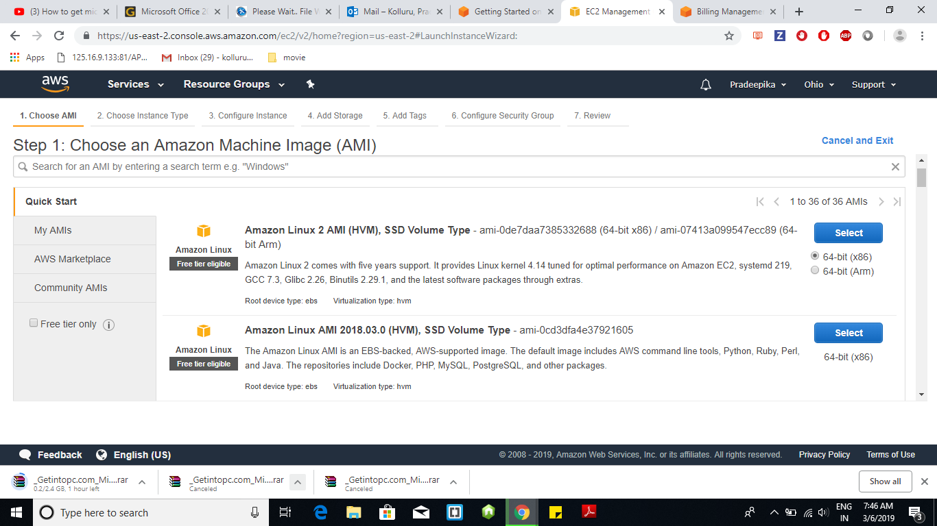

**Step-3 :** In Configure Security Group add Http by clicking on ADD RULE and proceed with Review and Launch

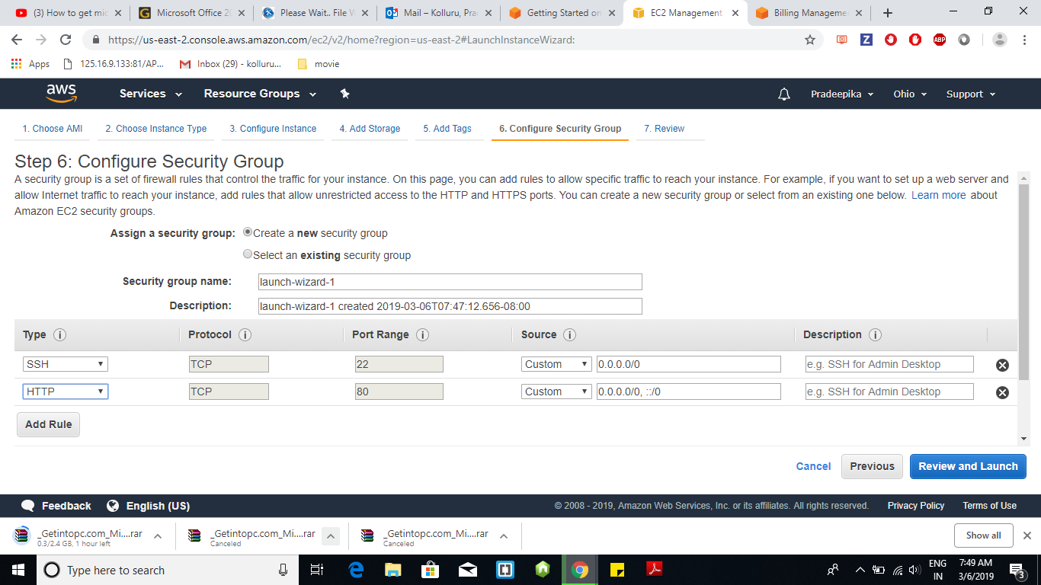

**Step-4 :** Proceed with Launch and download key pair.

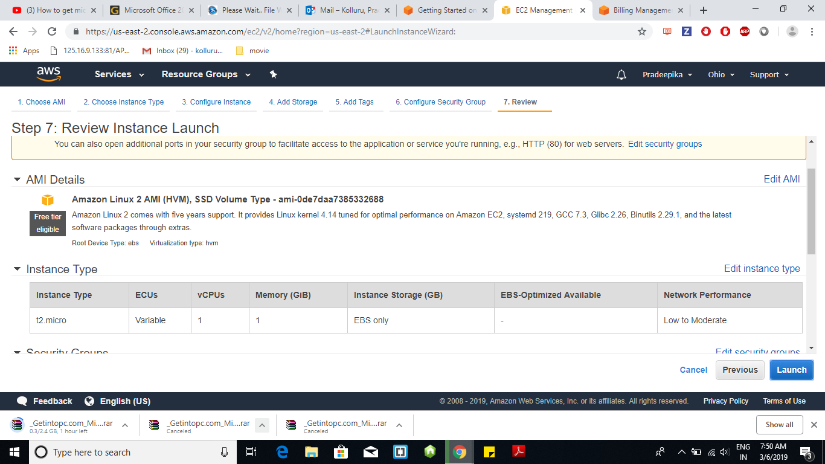

**Step-5 :** Choose new key pair option and give a name for key. Thereafter Download Key pair. File downloads with .pem extension.

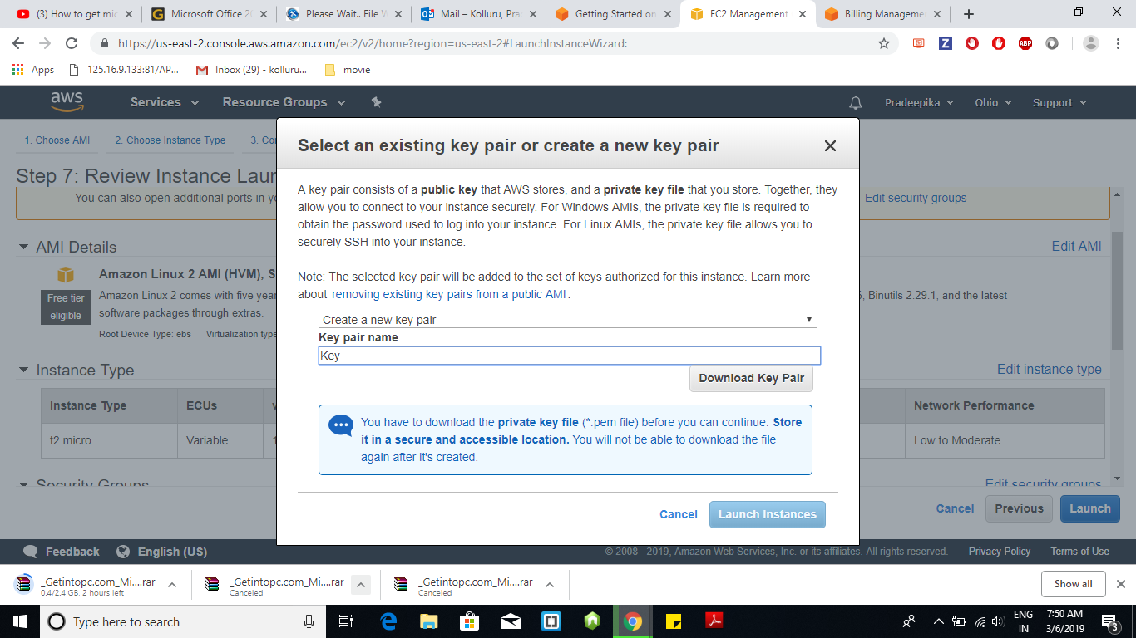

**Step-6 :** Open Instance page created and click on Connect to Instance

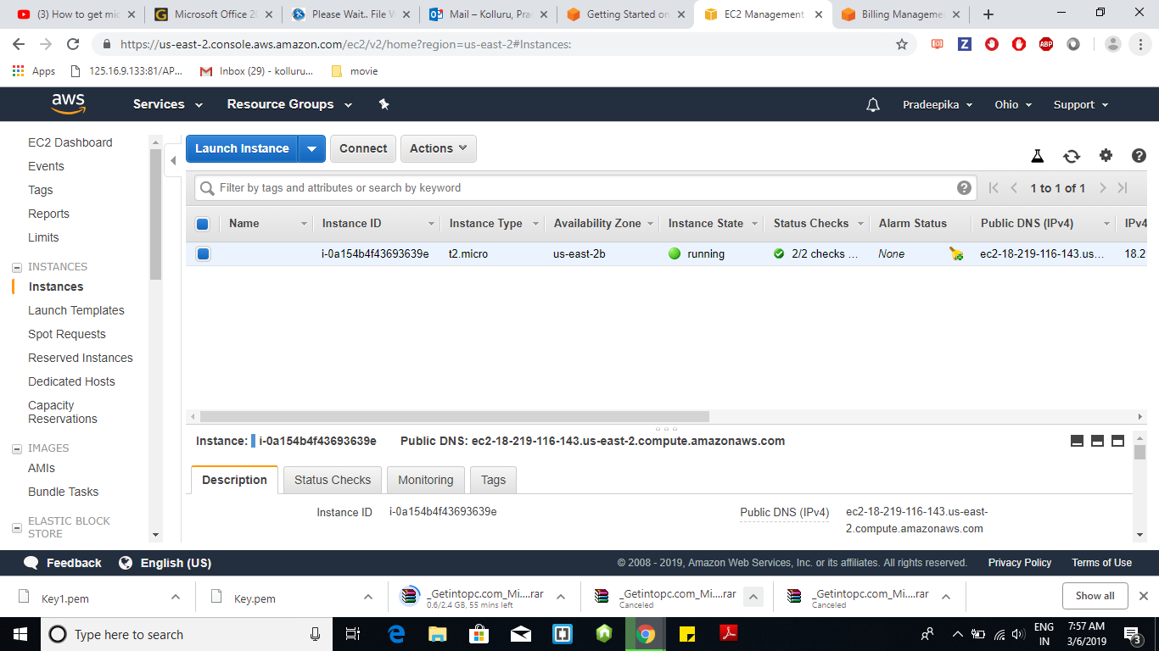

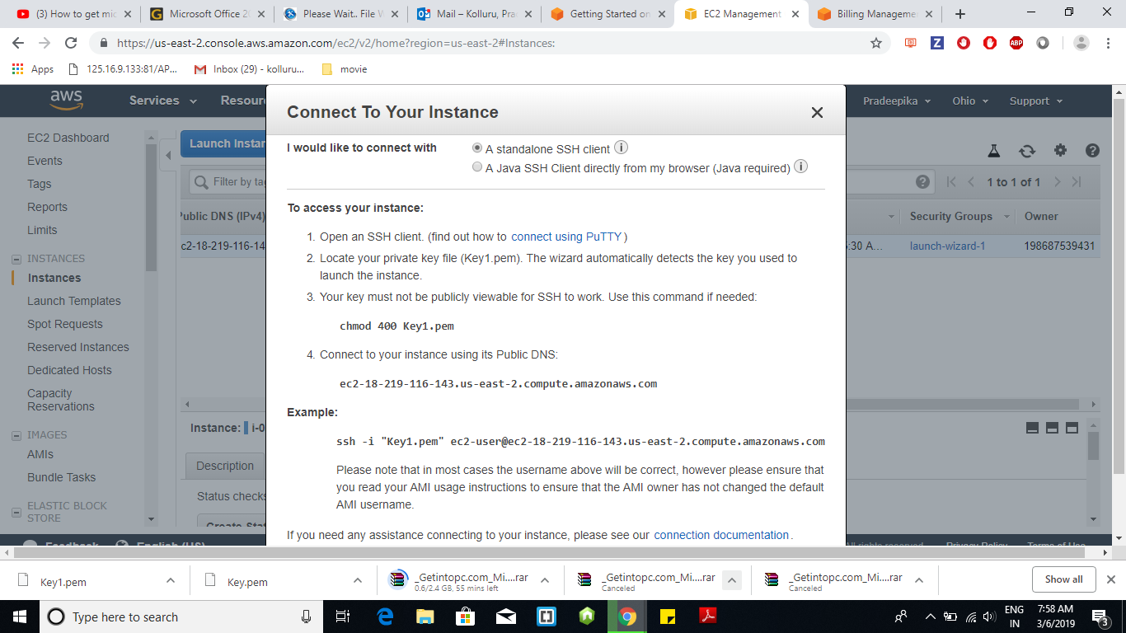

**Step-7 :** Go to puttyGen and load the downloaded key pair file and convert it to .ppk file so that putty can read the file. Open putty and add Public DNS in Hostname and add .ppk file in Auth

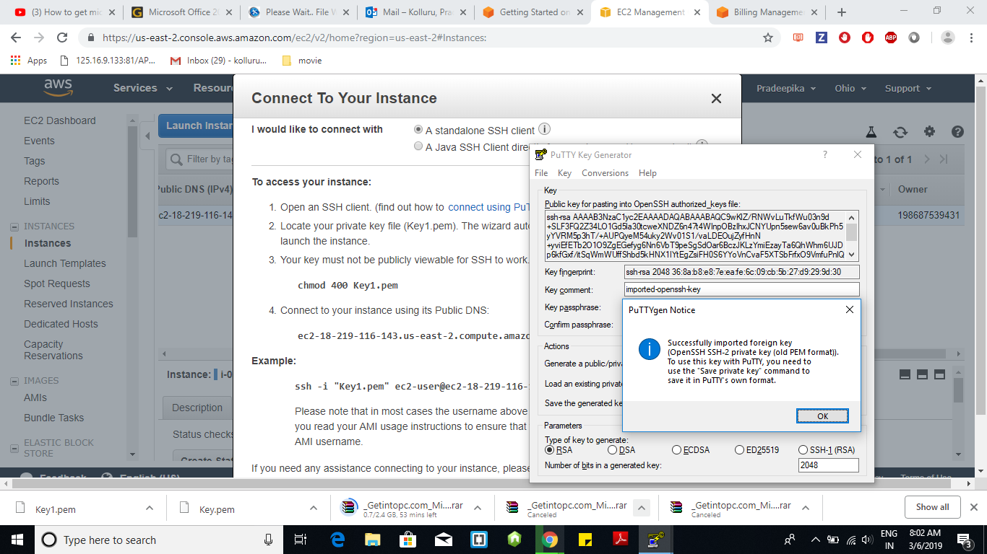

**Step – 8 :** Login with “ec2-user” in putty and run the following commands.

Sudo yum update, sudo yum install httpd, sudo apachectl start

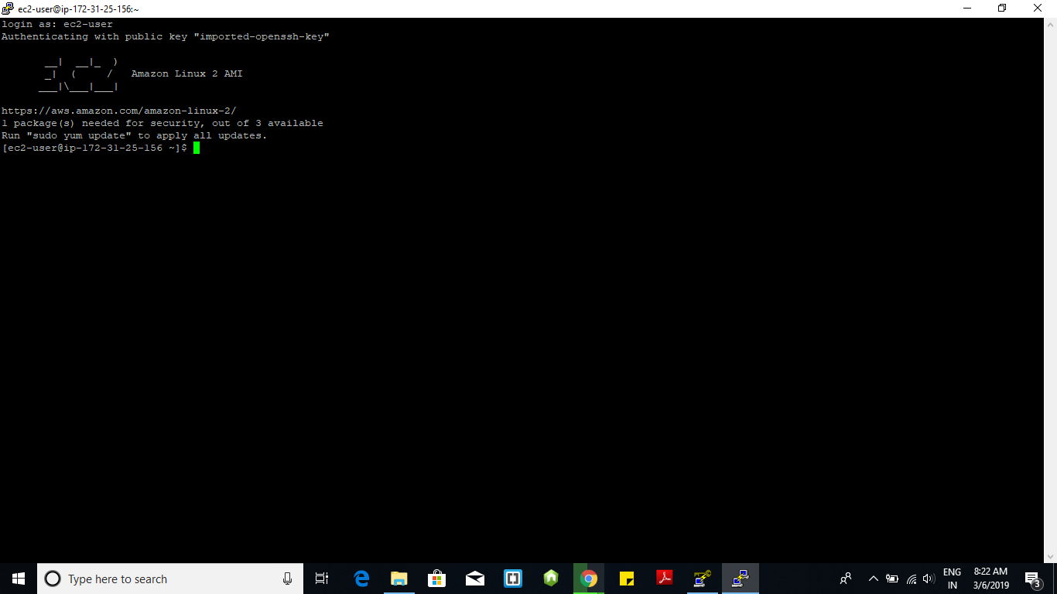

**Step-9 :** The output of html can be seen in the IP address given in AWS website

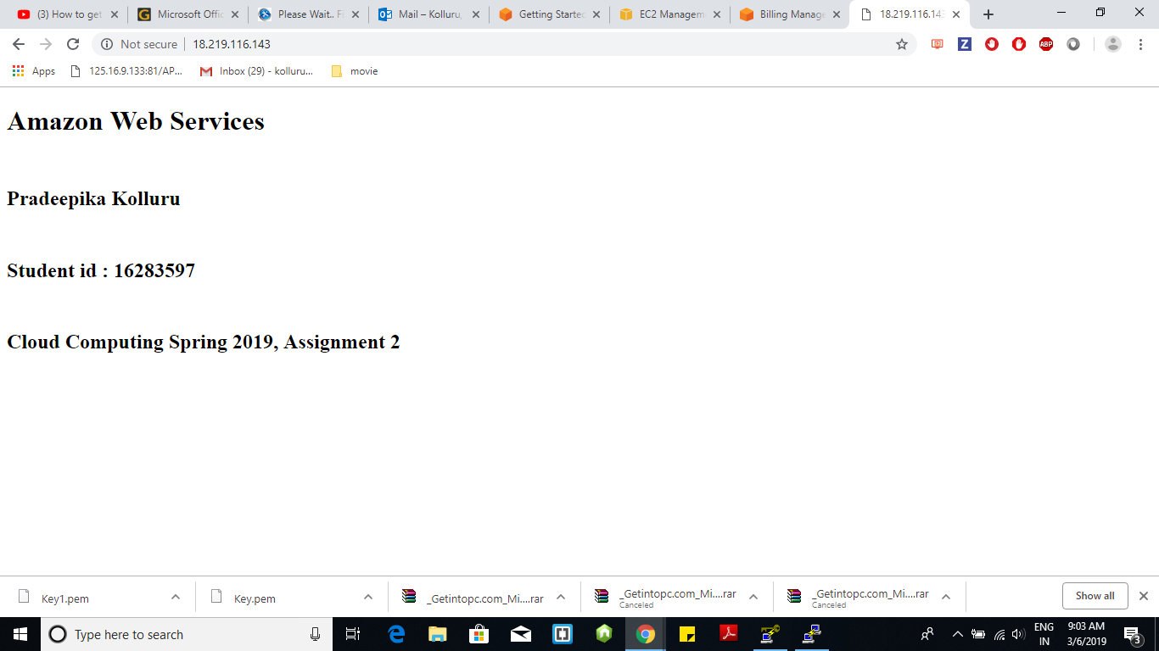

**Cloud Platform : Microsoft Azure**

**Step -1 :** Login to Microsoft Azure website and open Create Virtual Machine in Virtual Machines

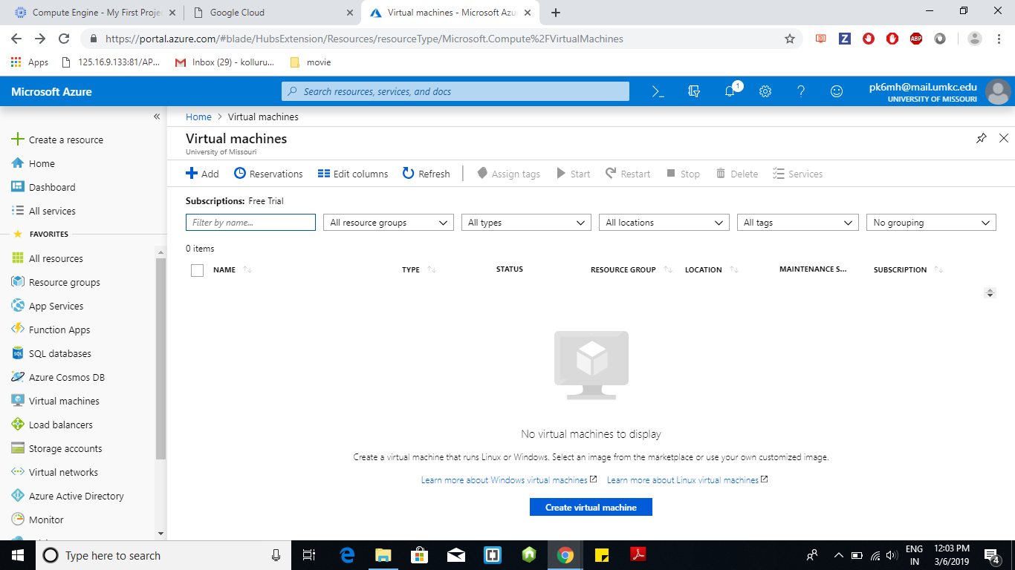

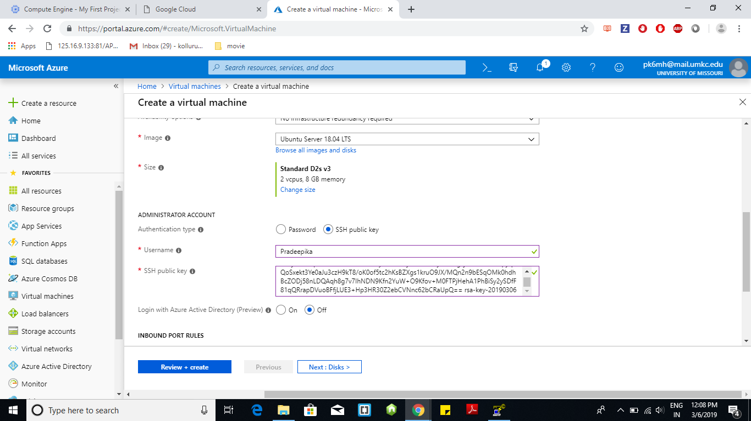

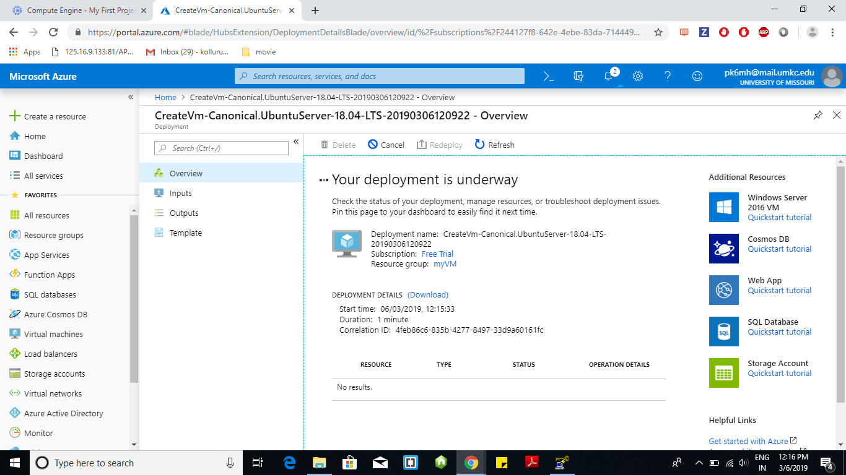

**Step-4 :** Open Putty and give Host name and key which is generated by using PuttyGen

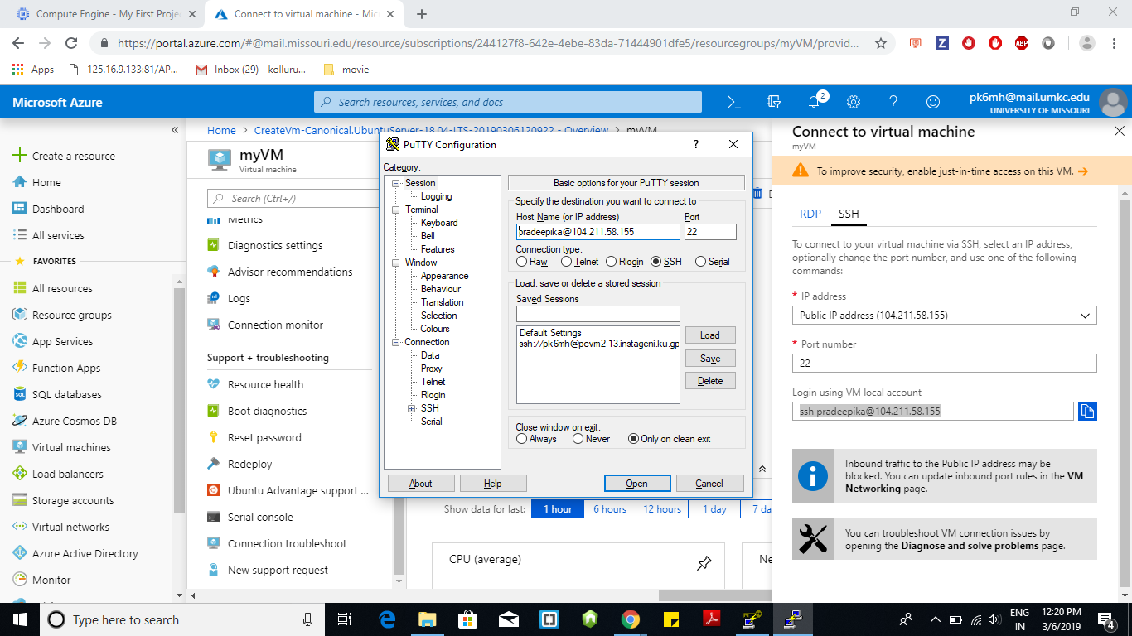

**Step-5 :** Login to putty by using the passphrase given in PuttyGen and run the following commands : Sudo app-get aupdate, sudo app-get install apache2 –y. Write html script by using echo command and pipe it to sudo tee /var/www/html/index.html

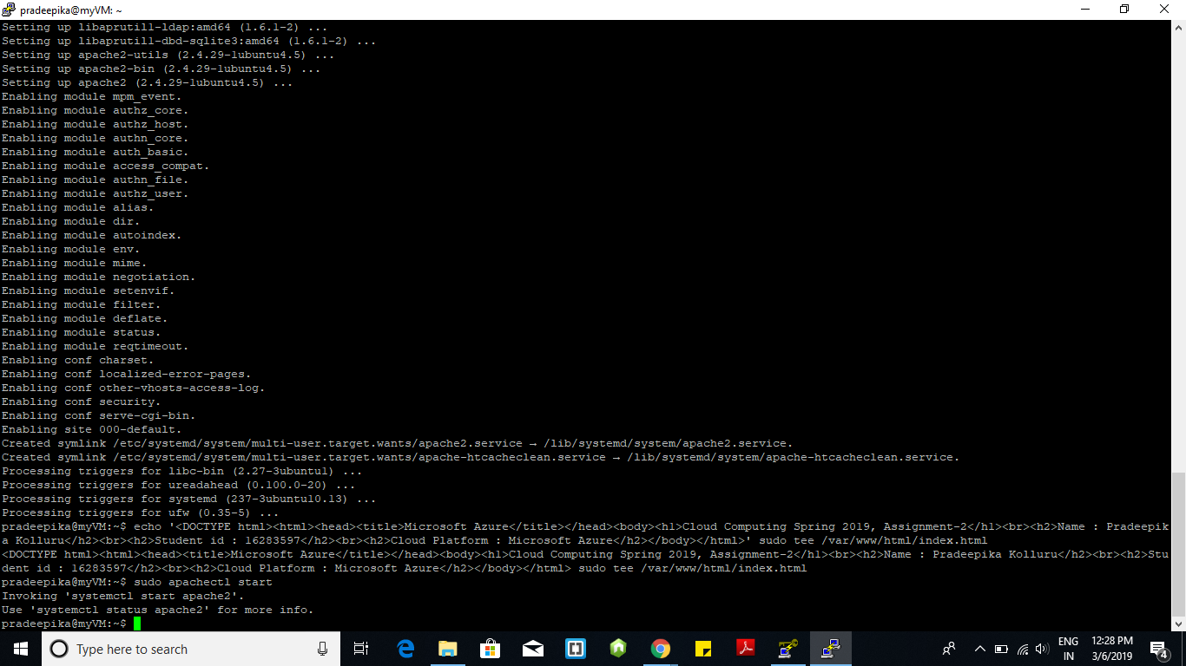

**Step- 6:** The output of html can be seen in the IP address given in Microsoft Azure website

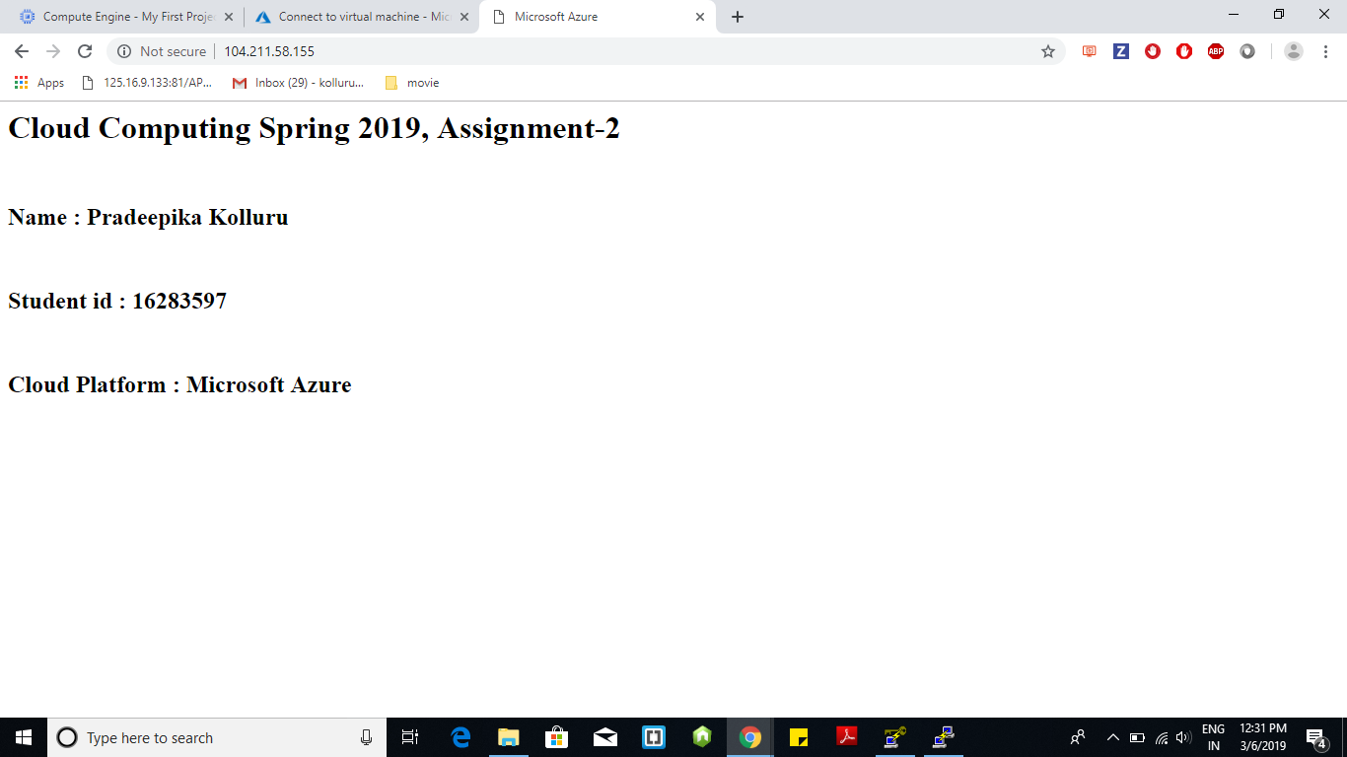

**Cloud Platform : G Cloud**

**Step-1 :** Open account in G cloud and Select compute engine followed by Create

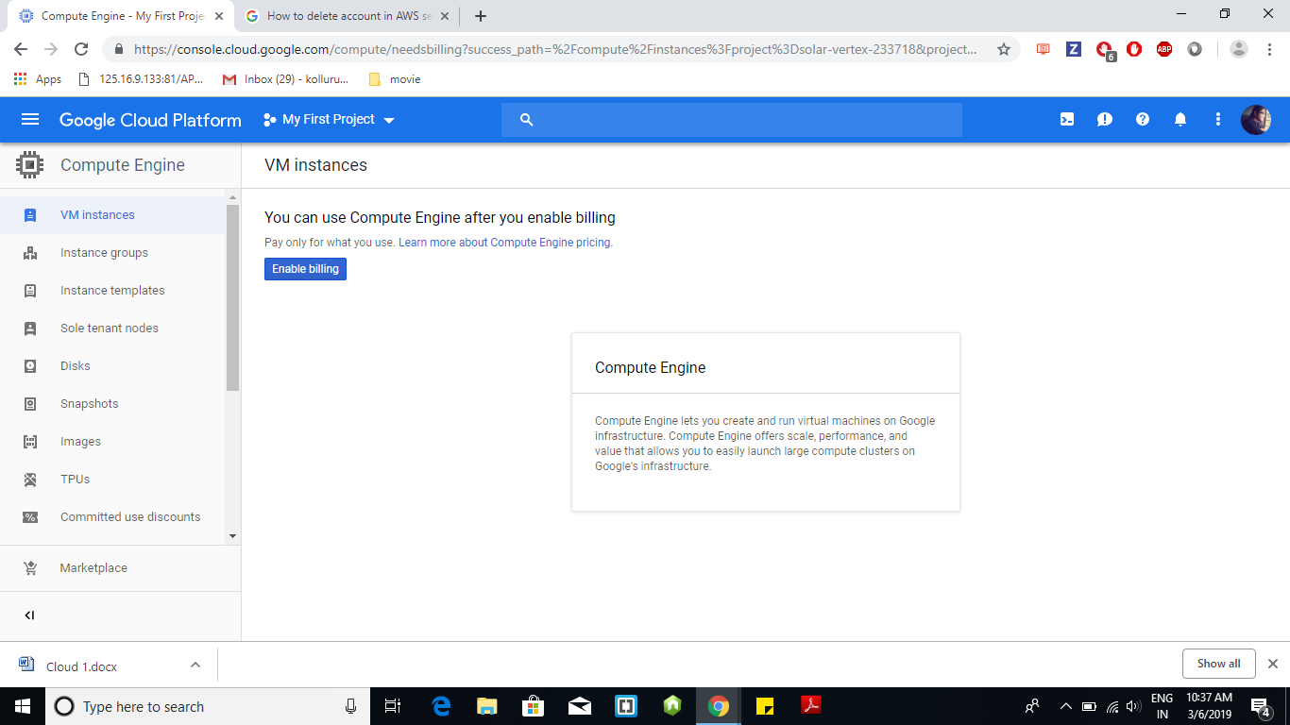

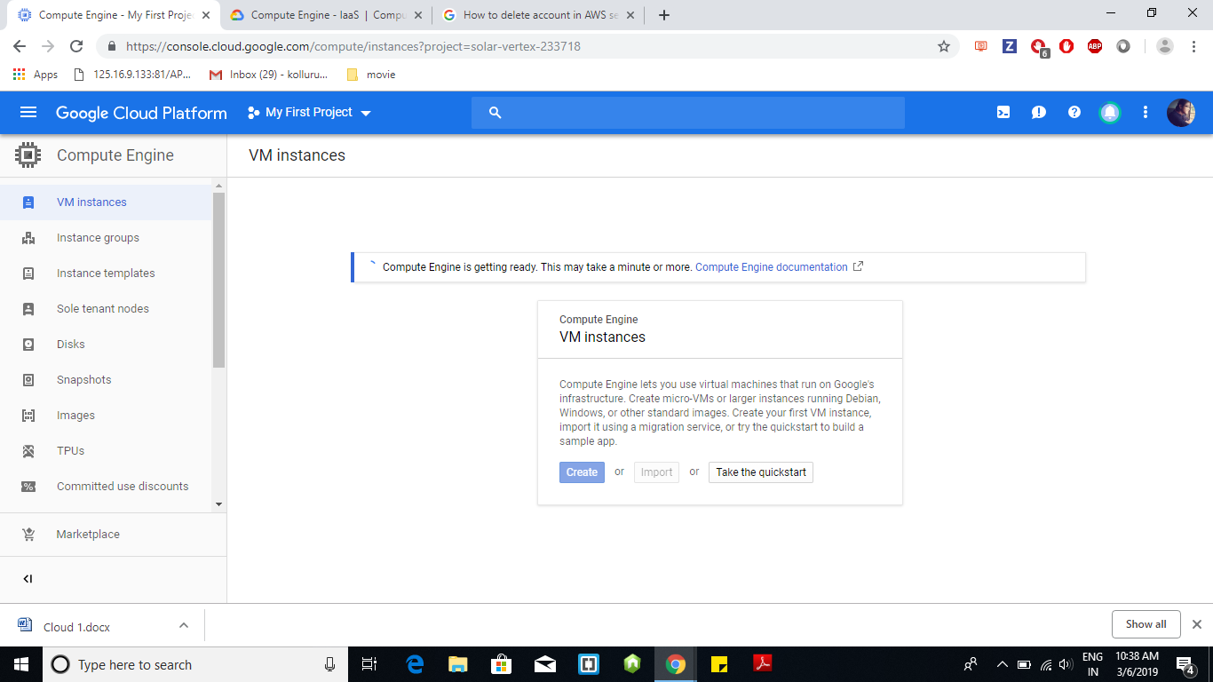

**Step-2 :** Open Linux Based Gcloud Window by clicking on SSH and execute the following commands : sudo apt-get update, sudo apt-get install apache2 –y and use echo command to create html file and pipe it with sudo tee /var/www/html/index.html

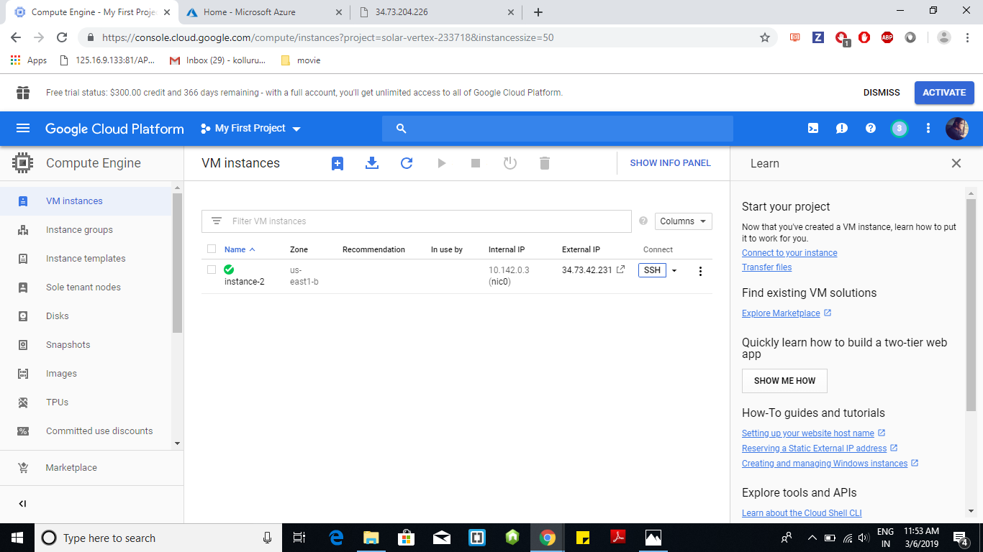

**Step -3 :** To display the output file, Click on the External IP hyper link

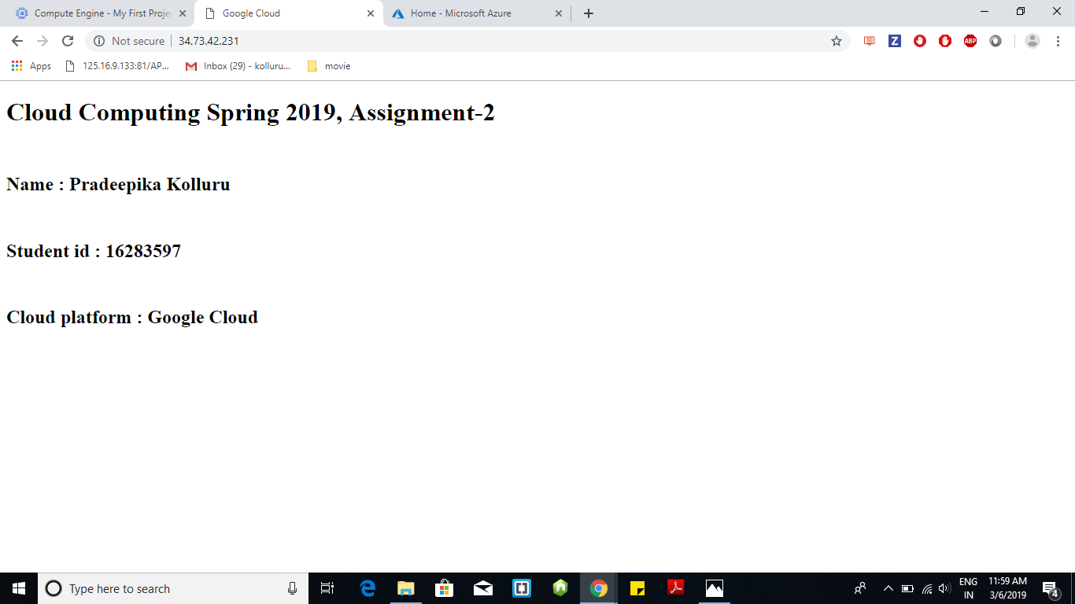

**Epilog**

1. Get it know how to deploy a webpage on Google Cloud Platform, Microsoft Azure, Amazon AWS
2. The fun part of this assignment is creating accounts in different cloud platforms and the difficult part is converting .pem file to .ppk . I struggled in opening .pem file in putty then I got to know that putty accepts .ppk files and I converted .pem to .ppk using PuttyGen
3. I used Google cloud, Microsoft Azure and Amazon AWS to complete this assignment. In my opinion deploying web page in Google Cloud is easy when compared other two, Geni, Cloud lab because Google Cloud is providing Open Linux based G Cloud window. Therefore, no need of using putty.